Sample Paper for A4 Page Size
First Author^{#1}, Second Author^{*2}, Third Author^{#3}
#First-Third Department, First-Third University
Address Including Country Name
¹first.author@first-third.edu
³third.author@first-third.edu
*Second Company
Address Including Country Name
²second.author@second.com

Abstract— This document gives formatting instructions for authors preparing papers for publication in the said journal. The authors must follow the instructions given in the document for the papers to be published. You can use this document as both an instruction set and as a template into which you can type your own text.
This template preserves much of the standard LATEX interface so that authors can easily convert their standard LATEX article style files to the required style.
Keywords— Include at least 5 keywords or phrases
- Introduction
When you submit your paper print it in one-column format, including figures, equations and tables. In addition, designate one author as the “corresponding author”. This is the author to whom proofs of the paper will be sent. Proofs are sent to the corresponding author only.
- Page Size and Layout
Set your page as A4, width 210, height 297 and margins as follows:
- Left Margin 17.8 mm (0.67")
- Right Margin 14.3 mm (0.56)
- Top Margin – 17.8 mm (0.7")
- Bottom Margin – 17.8 mm (0.7")

- Title and authors
The title of the paper is centred 17.8 mm (0.67") below the top of the page in 24 point font. Right below the title (separated by single line spacing) are the names of the authors. The font size for the authors is 11pt. Author affiliations shall be in 9 pt.
  - Body paragraphs
The main text for your paragraphs should be 10pt font. All body paragraphs (except the beginning of a section/sub-section) should have the first line indented about 3.6 mm (0.14").
    - Figures and Tables
Place illustrations (figures, tables, drawings, and photographs) throughout the paper at the places where they are first discussed in the text, rather than at the end of the paper. Number illustrations sequentially (but number tables separately). Place the illustration numbers and caption under the illustration in 10 pt font. Do not allow illustrations to extend into the margins. If your figure has two parts, include the labels “(a)” and “(b)”.

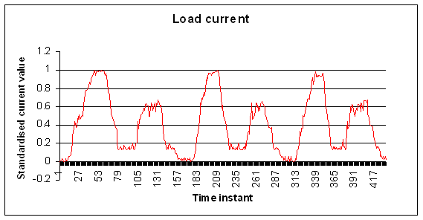
Figure 1. Testing data- load current (amperes)
    - Tables
Place table titles above the tables.
Table 1. Best results
____________________________________________________________________________________
International Journal of Latest Trends in Networks & Communication
IJLTNC, E-ISSN: 2047-8895
Copyright © ExcelingTech, Pub, UK (http://excelingtech.co.uk/)

Load time | Frequency | Total Cost
Seconds | Eight | None
Minutes | Nine | More

    - Sections headings
Section headings come in several varieties:
- first level headings: 1. Heading 1
- Second level: 1.2. Heading 2
- third level: 1.2.3 Heading 3
- forth level: (a) Heading 4
- fifth level: (1) Heading 5
- sixth level: (a) Heading 6

    - References
Number citations consecutively in square brackets [1]. The sentence punctuation follows the brackets [2]. Multiple references [2], [3] are each numbered with separate brackets [1]–[3]. Please note that the references at the end of this document are in the preferred referencing style. Please ensure that the provided references are complete with all the details and also cited inside the manuscript (example: page numbers, year of publication, publisher’s name etc.).
- Equations
Equations should be typewritten whenever possible and the number placed in parentheses at the right margin. If you are using Word, use either the Microsoft Equation Editor or the MathType add-on (http://www.mathtype.com) for equations in your paper (Insert | Object | Create New | Microsoft Equation or MathType Equation). “Float over text” should not be selected.
Number equations consecutively with equation numbers in parentheses flush with the right margin, as in (1). First use the equation editor to create the equation. Then select the “Equation” markup style. Press the tab key and write the equation number in parentheses.
Reference to equations should use the form “Eq. (1)”
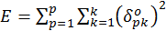 (1)
- LATEX
If the author using LATEX interface for the paper, so that authors can easily convert their standard LATEX article style files to the required style.
The file should look like this:

\documentclass{jcmlatex}
\def\IJLTNCvol{xx}
\def\IJLTNCno{x}
\def\IJLTNCyear{xxxx}
\setcounter{page}{1}

\begin{document}

\markboth{authors list in InitialCap case}{Title in Title Case}

\title{make the title in InitialCap case}

\author{First Author
\thanks{Address and email for first author}
Second Author
\thanks{Address and email for second author} \and
Third Author
\thanks{Address and email for third author} }

\maketitle

\begin{abstract}
Text here, no equation, no citation, no reference.
\end{abstract}

\begin{keywords}
List here.
\end{keywords}

\section{First Section}

\end{document}

Acknowledgments
The authors would like to thank....

References
- Author 1, Author 2, “Title of paper”, Name of Journal, Vol xx, No. x, pp. x-x, Year.
- Author(s), “Title of the proceedings paper”, name of the conference, Publisher, Country, pp.x-x, Year
- Author(s), “Title of the Thesis”, PhD thesis, ABC University, Year
- Author(s), this is a book title, publisher, Year
- Title of Web Page, Webaddress, Last access/date of visit (dd-mm-yyyy)

